~ YAMS ~
(Yet Another MIPS Simulator)

Table of Contents

Welcome to YAMS!

Using YAMS Console
- Command line options
- Interpreting output

Using YAMS GUI
- Command line options
- Adding files
- Loading a file
- Adding breakpoints
- Controlling execution
- Interpreting output

Adding instructions

Notes for the compiler lab

Welcome to YAMS! | TOP

YAMS is a simulator for the MIPS processor, which runs a RISC (Reduced Instruction Set Chip) architecture. As a simulator, it's main task is to correctly simulate a given set of assembler instructions and produce any necessary output. In addition, there are many features that let you see exactly what is happening as each instruction is executed, such as register and memory contents. YAMS also includes a comprehensive statistics module so you can see just how efficient the assmebly code is.

The YAMS package will work in two formats – in a console that will run from a command line, and in a user friendly graphical version, so you can see clearly what is happening inside the processor as the assmebly program is being executed.

Using YAMS – Console Version | TOP

Command Line Options

You can run YAMS from the command line by navigating to the directory where the executable is held, and typing YAMS –console, along with the following options:

YAMS [OPTIONS] [FILENAMES]

[Options]
-s, --stats Outputs statistics from the run of the program

-v, --verbose Runs the program in verbose mode. Recommended only for advanced users or debugging as this can output a lot of text.

-if <file> Input a list of files – the proceeding filename is a text file containing a list of files that should be executed by the simulator.

[Filenames] Input files – One or more input files can be specified to be run by YAMS. If more than one is specified, they will be run in turn and the output for each displayed in the console window.

Examples:
YAMS –console --stats –if filelist.txt
YAMS –console file1.asm file2.asm

Handy Hint:
If there is too much text output on the screen, you can redirect the output to go to a seperate file so you can look at it in a text editor instead. Do this by using the output redirect character ‘>’. In the example above, this would be:

YAMS –console --stats –if filelist.txt > outputfile.txt

Interpreting the Output

Standard Mode

When running in the console mode on a single file, YAMS will first parse the file to make sure it is syntactically correct and all the instructions are valid. If an error is encountered, the type of error and line number in the assembly program where it was found are reported on the screen. For example:

=====STARTING NEW FILE=====
Input File: square.asm
Parser Error:Parse error at line: 14
Unsupported Instruction ‘lkj’

If no errors are found, the output by YAMS will just be the same as the output of the program. An example run is shown below:

=====STARTING NEW FILE=====
Input File: square.asm
1111111111
0111111111
0011111111
0001111111
0000111111
0000011111
0000001111
0000000111
0000000011
0000000001
0000000000

Statistics Mode

When the statistics option is turned on, YAMS will also output the following statistics after the file has been executed :
- How many times each line of the program was executed
- How many times each instruction was used
- How many times each register was used
- The total number of CPU cycles required
- The total memory required.

An example of the output is show below:
=====STARTING NEW FILE=====
Input File: EvalExpr.asm
Output of the program
1234

==============
STATISTICS
==============

------------LINES EXECUTED------------

Line Count
9 li $t0,10: 1
10 sw $t0,_x: 1
11 li $t6,1: 1
12 lw $t7,_x: 1
13 mul $t5,$t6,$t7: 1
14 li $t6,2: 1
15 add $t4,$t5,$t6: 1
16 lw $t5,_x: 1
Number of times each line executed
17 mul $t3,$t4,$t5: 1
18 li $t4,3: 1
19 add $t2,$t3,$t4: 1
20 lw $t3,_x: 1
21 mul $t1,$t2,$t3: 1
22 li $t2,4: 1
23 add $t0,$t1,$t2: 1
24 sw $t0,_x: 1
25 lw $a0,_x: 1
26 li $v0,1: 1
27 syscall: 1
28 la $a0,_newline: 1
29 li $v0,4: 1
30 syscall: 1
31 # exit call to Stop the program
32 li $v0,10: 1
33 syscall: 1

-----------INSTRUCTIONS USED-----------

Instr Count
ADD: 2
ADDI: 9
Number of times each instruction used
BEQ: 5
BNE: 3
LUI: 1
LW: 7
ORI: 6
SW: 3

------------REGISTERS USED------------

Reg Count
$0: 27
Number of times each register used
$1: 4
$2: 4
$4: 4
$8: 2
$9: 8
$10: 2
CPU Cycles and total memory used
CPU CYCLES: 313

MEMORY USED: 65 WORDS

Using YAMS – GUI Version | TOP

Command Line Options

To use the GUI version of YAMS, navigate to the directory where the executable is held, and type YAMS –gui, along with the following options:

YAMS –gui [-if <file>] | [FILENAMES]

-if <file> Input a list of files – the proceeding filename is a text file containing a list of files that should be executed by the simulator.

[Filenames] Input files – One or more input files can be specified to be run by YAMS. If more than one is specified, they will be run in turn and the output for each displayed in the console window.

The graphical interface will then launch and show the screen below:

Code Execution

Filelist Box

Breakpoints / Code

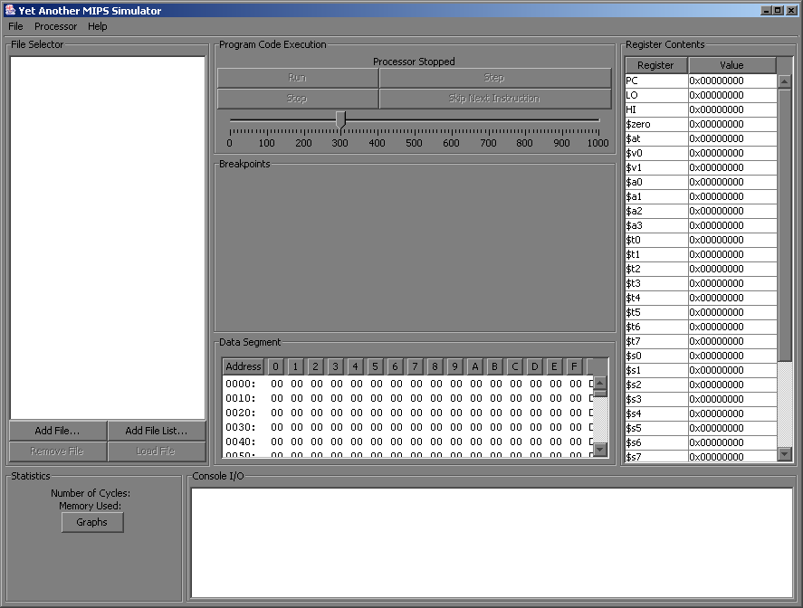

Console Output

Statistics

Register Contents

Console

Data Segment

Statistics

Adding Files to the File Selector Box

If input files were specified at the command line, they will be displayed in the File Selector Box. Otherwise, files can be added to the File Selector Box by clicking Add File and then using the dialogue box to add a file.

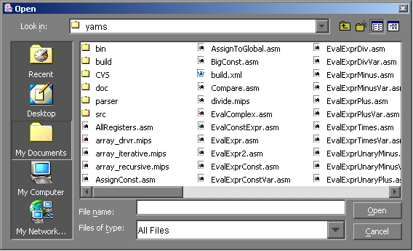

Here you can select an assembly file to load into the simulator.

To add a list of files, click the ‘Add Filelist’ button, and select the file that contains the list of assembly files you wish to load. The filelist should contain the file names of the assembly files, one per line.

If you wish to remove a file from the list, select it in the list box, then click the Remove File button below.

Loading a File

Once you have chosen the file you wish YAMS to simulate, you can then load the file by pressing the ‘Load File’ button.

The program code, memory locations and register contents are shown once the file is loaded, as can be seen below, with the first line of code highlighted.

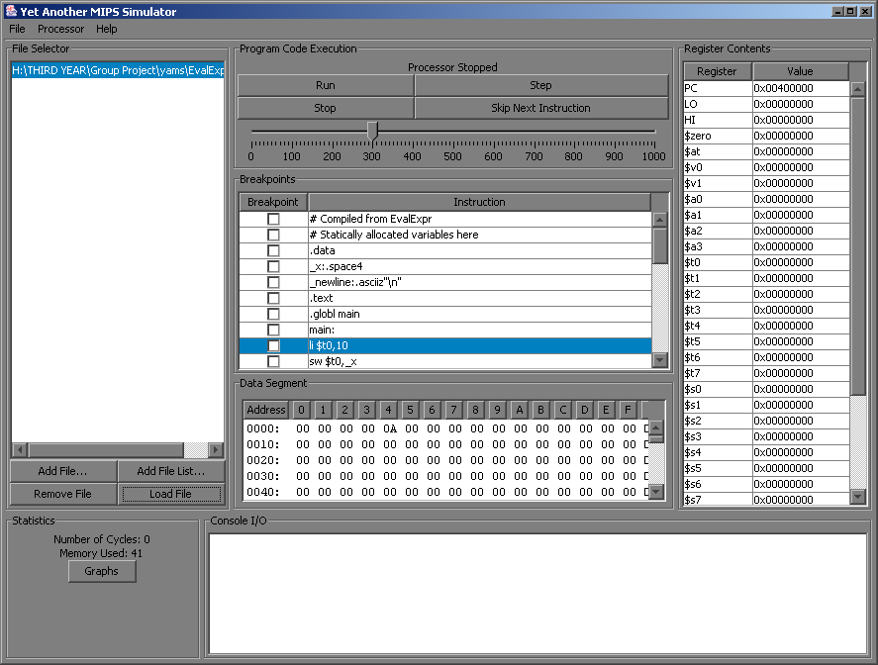

Adding Breakpoints

Adding a breakpoint to the program is simple. Just use the checkbox that is next to the line you where you wish to pause execution. When the simulator reaches here, you can examine the contents of the register and memory locations.

Controlling Execution

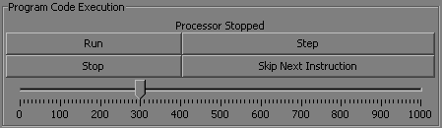

Speed
The speed of the processor can be controlled by the slider bar – a larger value means a longer gap between each instruction so you are able to execute the program in ‘slow motion’.

Run
Press the Run button to begin the execution of the assembly program. The execution of the program is done slowly line by line so that you can see each line being executed individually and the contents of the registers and memory changing. The current line being executed is shown by the highlighted line in the program code.

Stop
To Stop the execution of the program, press the ‘Stop’ button. The instruction that is currently being executed will remain highlighted. From here, it is possible to resume the execution of the program by pressing ‘Run’, run just the next instruction by pressing ‘Step’ or skip the next instruction by pressing the ‘Skip Next Instruction’ button.

Single Step
If you wish to single step each line of the program, first of all, press the Stop button which will pause the programs execution. It is then possible to use the Step button to execute each instruction one at a time. Note that one line of assembly code can be made up of several processor operations, so pressing Step will not always move to the next instruction, but will execute the next processor operation for that line.

Skip
Pressing ‘Skip Next Instruction’ will ignore the next insturction that is to be executed. It is recommended that this feature is used while in stepping mode so that it can be seen clearly which instruction is to be skipped.

Interpreting Output

Console Output
The Console I/O box is used for 2 things:
- Error messages from the parser – if an error was encountered while parsing the assmebly file, the type of error and related line number are displayed. Correct the error then try loading the file again.

- Output of the program – during the execution of the program, any output is displayed in the Console I/O box.

Statistics
Statistics for the run of the program are available in the Statistics Panel of the interface. This shows the number of CPU cycles required so far for the program executing, and the total amount of memory used by the program. These are updated constantly as the program is executed.

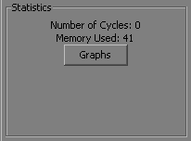

Pressing the ‘Graph’ button will display a window with 2 tabs:
- How many times each register was used
- How many times each line was executed

This can be useful in seeing where loops are in the program as the lines in the loop are executed more often than the rest of the instructions.

Adding Instructions | TOP

YAMS uses XML technology which makes it incredibly easy and flexible to add new instructions to the instruction set. To add an instruction, all you have to do is….
Help me jimmie!

Notes for the Compiler Lab | TOP

